NORTON’S THEOREM
STEP I – To Find I_{N} or I_{SC}
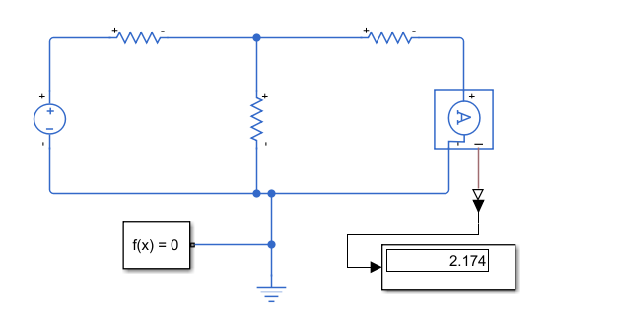

STEP 2 – To Find RN (RN = V / I)
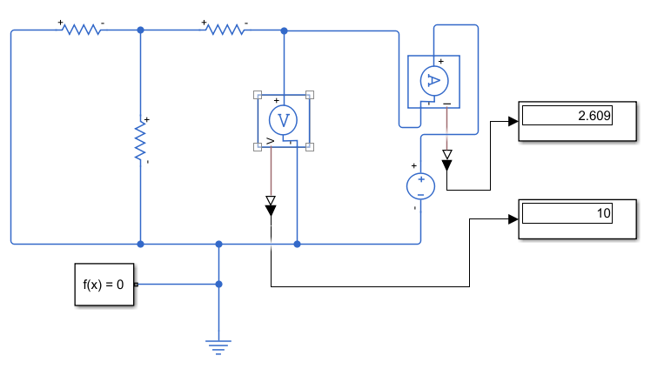

STEP 3 – To Find the load current (IL)
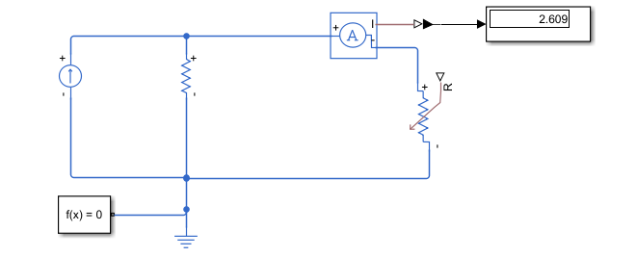

NORTON’S THEOREM
STEP I – To Find I_{N} or I_{SC}

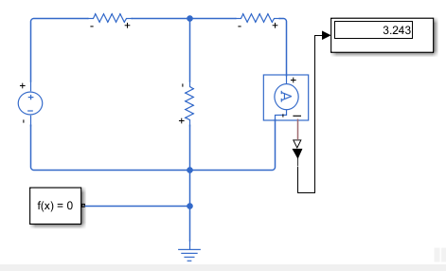

STEP 2 – To Find RN (RN = V / I)
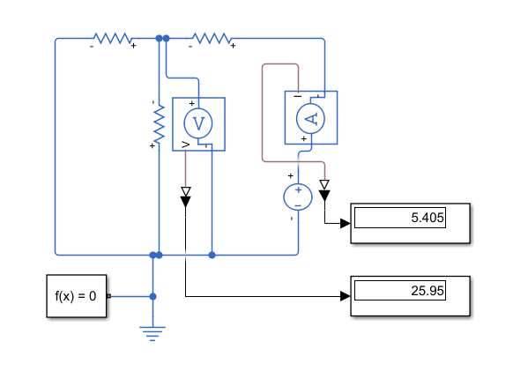
STEP 3 – To Find the load current (IL)
